Developer Manual

Environment: The environment used for developing Chasing the End is Unity 2018.2.14f1 and can be used in previous versions. Chasing the End can be accessed at: <https://github.com/CS383-Dream-Team/Chasing-the-End>

Just follow the ReadMe instructions and enjoy.

Context Diagram:

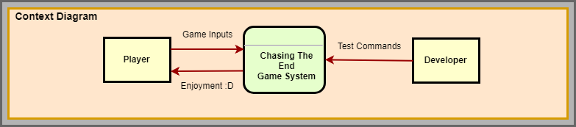

Class Diagrams:

Tyler:

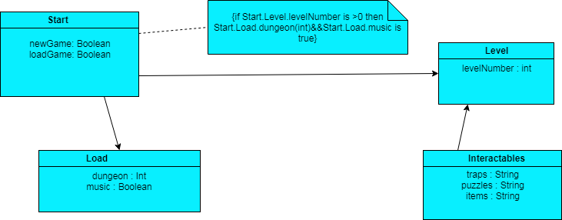

Luke:

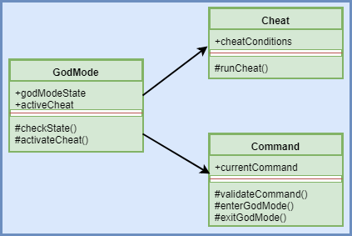

Brad:

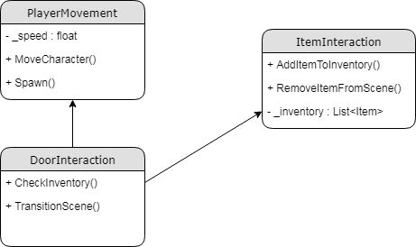

Edgar:

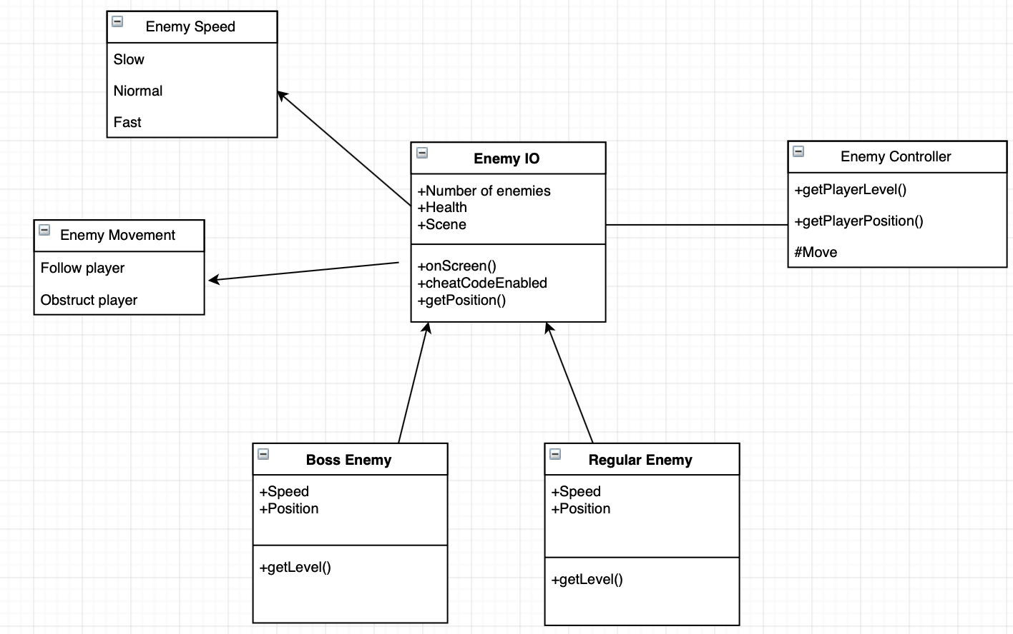

Jorge: